CS 3332 – PROJECT (Homework 1-6)
GROUP X
Members:
No. | Student Name | Student ID
1
2
3
4
5

We removed the programming exercise sections since they’re not required.

Assignment for Lecture 1-2:
Exercise 1
Write a paragraph introducing about a software and the benefits it brings to you. Explain the type of the software (generic or customize).
STUDENT:
SOLUTION: | Facebook is a social media software that helps me connect with friends, family, and other people online. I can use it to send messages, share photos, watch videos, join groups, and follow news or pages that I like. It is useful because it makes communication faster and helps me stay updated with people and events around me. Facebook is a generic software because it is made for the public, not for one specific person or company or organization.

Exercise 2
What differences that Web made to SE?
STUDENT:
SOLUTION: | The Web changed software engineering by making software accessible through browsers instead of only local computers. It also changed deployment and maintenance because software can be installed and updated on web servers, so users do not need to update separate programs on every PC. Web systems also need better scalability because many users may access them at the same time, and stronger security because they are connected through networks. In addition, the Web made user experience more important, including speed, interface, navigation, and content quality. Overall, software engineering moved toward distributed, reusable, and continuously updated web-based systems.

Exercise 3
Trace the problem one would face, if he tries to develop a large software product without using software engineering principles.
STUDENT:
SOLUTION: | If a large software product is developed without software engineering principles, many problems can happen. First, the requirements may be unclear, so the final product may not meet users’ needs. Second, poor design can make the system hard to understand, test, and improve. Without proper reviews and testing, bugs and defects may remain until late stages, where they are more expensive to fix. The project’s time can be extended, leading to late final results, cost more than expected, and become unreliable. Teamwork can be poor because large software usually needs teams, documentation, and clear communication. Finally, maintenance becomes difficult because changes are almost impossible and badly designed, or badly documented software is harder and more expensive to correct, adapt, or enhance.

Exercise 4
Choose a type of application. Searching information on Internet about an application belong to this type.
STUDENT:
SOLUTION: | I have selected Systems for modeling and simulation for this assignment. A prominent real-world example of this application type is MATLAB (Matrix Laboratory), often used in conjunction with Simulink. MATLAB serves as a high-level programming language and environment specifically engineered for numerical computing, visualization, and programming.  This software functions as a robust system for modeling and simulation by enabling users to construct "Digital Twins," which are highly accurate in virtual representations of physical assets, processes, or entire systems. The integration of Simulink provides a block diagram environment ideal for multi-domain simulation and Model-Based Design. This setup is essential for designing intricate systems that require precise control logic or advanced signal processing.  Engineers utilize these tools to perform high-level tasks such as analyzing massive datasets, developing new algorithms, and creating predictive models. These models can simulate how a system will behave under extreme or dangerous conditions without any risk of physical failure. Consequently, MATLAB has become a standard tool in critical industries, including Aerospace for flight dynamics, Automotive for electric vehicle battery management, and Robotics for sensor fusion and path planning. Further information regarding these capabilities can be found at the official source: https://www.mathworks.com/products/matlab.html.

Exercise 1.1
By making reference to the distribution of software costs discussed in Section 1.1.6, explain why it is appropriate to consider software to be more than the programs that can be executed by end-users of a system.
STUDENT:
SOLUTION: | According to Sommerville's book on software cost distribution, viewing software as more than just executable programs is entirely logical, as a large portion of the budget and resources are invested in activities outside of programming. In fact, evolution and maintenance costs often account for over 60% of a system's total cost, demonstrating that the software lifecycle is significantly longer than the initial coding phase. Furthermore, technical processes such as requirements definition, architectural design, and testing typically cost more than programming itself. This confirms that the concept of "software" must encompass a complete set of assets, including documentation, configuration data, and system instructions, as these are essential elements for ensuring the system can operate, be maintained, and provide long-term value to end users.

Exercise 1.2
What are the differences between generic software product development and custom software development?
STUDENT:
SOLUTION: | The difference between generic and custom software development is clearly demonstrated in terms of market objectives and product control. Generic products are independent systems built for widespread sale to any customer, such as graphic editing tools or project management systems. Conversely, customized products are custom-ordered by a specific customer to address unique needs, such as air traffic control or traffic monitoring systems. In terms of product specifications, the generic software developer has the right to decide on features and changes, while with custom software, the customer owns the specifications and makes changes as needed.  From an operational perspective, generic software has the advantage of faster deployment and lower initial costs, but features are often limited by standards and security is not as high. Meanwhile, on-demand software requires longer development times and higher initial investment costs, but in return, it offers specific features, high scalability, strong security, and more flexible, long-term support. These characteristics help customers optimize their return on investment (ROI) in the long term, even if they have to accept a higher initial cost.

Exercise 1.3
What are the four important attributes which all software products should have? Suggest four other attributes that may sometimes be significant.
STUDENT:
SOLUTION: | All professional software products should consistently exhibit four fundamental attributes to be considered high-quality: maintainability, which allows the system to evolve with changing business needs; dependability and security, ensuring the software is reliable, safe, and resilient against attacks; efficiency, which focuses on the optimal use of system resources like memory and processor cycles; and acceptability, meaning the product is usable and compatible for its intended audience. Beyond these core traits, other attributes can become significant depending on the specific context, such as scalability for handling increased workloads, portability for operating across different hardware platforms, interoperability for seamless communication between independent systems, and usability to ensure a high-quality, accessible experience for all users.

Exercise 1.8
As software becomes more pervasive, risks to the public (due to faulty programs) become an increasingly significant concern. Develop a doomsday but realistic scenario in which the failure of a computer program could do great harm (either economic or human).
STUDENT:
SOLUTION: | The increasing reliance on embedded control systems in critical infrastructure can lead to disaster if software failures occur. A real-world scenario is a failure in the national grid's load balancing software during peak hours, causing transformer explosions and widespread power outages. Direct consequences include loss of life due to the shutdown of life support equipment in hospitals, as well as economic collapse as interactive transaction-based applications and supply chains are frozen. This scenario underscores that software is not just executable code but a complete product, where characteristics such as reliability and security are vital to preventing irreversible damage.

Assignment for Lecture 3:
Exercise 1
Write a summary paragraph about Waterfall model.
STUDENT:
SOLUTION: | The Waterfall model is a traditional software development methodology that follows a linear and sequential process, where each phase must be completed before the next one begins. Typical phases include requirements analysis, system design, implementation (coding), testing, deployment, and maintenance. Because of its structured nature, the Waterfall model works best when project requirements are clearly defined and unlikely to change. It emphasizes detailed documentation, planning, and strict control of progress. However, it can be less flexible than iterative methods such as Agile because changes are difficult and costly once development has moved to later stages.

Exercise 2
Find an example (on Internet) about a software developed using Waterfall model.
STUDENT:
SOLUTION: | A real-world example of software developed using the Waterfall model is software projects for NASA and the United States Department of Defense. These organizations have historically used Waterfall-style processes because their systems require extensive documentation, strict quality assurance, and stable requirements before development begins. For example, aerospace and defense control systems often follow a sequential lifecycle where planning, design, coding, testing, and verification must be completed carefully due to high reliability and safety requirements.

Assignment for Lecture 4:
Exercise 2.1
Giving reasons for your answer based on the type of system being developed, suggest the most appropriate generic software process model that might be used as a basis for managing the development of the following systems:
- A system to control anti-lock braking in a car
- A virtual reality system to support software maintenance
- A university accounting system that replaces an existing system
- An interactive travel planning system that helps users plan journeys with the lowest environmental impact
STUDENT:
SOLUTION: | For “A system to control anti-lock braking in a car”, i suggest using a waterfall model, because this is a safety-critical system, so requirements must be clear and fully checked before implementation.  For “A virtual reality system to support software maintenance, I suggest using Incremental development, because The requirements are likely unclear at first, so prototypes and user feedback are needed.  For “A university accounting system that replaces an existing system”, I suggest using reuse-oriented development, because accounting systems are common, so existing software or components can probably be reused and adapted.  For “An interactive travel planning system that helps users plan journeys with the lowest environmental impact”, I suggest using incremental development, because it is interactive and user-focused, so the system should be improved gradually based on user feedback.

Exercise 2.2
Explain why incremental development is the most effective approach for developing business software systems. Why is this model less appropriate for real-time systems engineering?
STUDENT:
SOLUTION: | Incremental development is effective for business software systems because business requirements often change. By developing the system in small increments, users can try early versions and give feedback. This helps the system better match real business needs and allows useful functions to be delivered earlier.  However, incremental development is less appropriate for real-time systems engineering because real-time systems usually have strict timing, safety, and performance requirements. The whole system architecture often has to be designed carefully before implementation, because adding parts later may affect timing, reliability, and system control.

Exercise 2.5
Describe the main activities in the software design process and the outputs of these activities. Using a diagram, show possible relationships between the outputs of these activities.
STUDENT:
SOLUTION: | 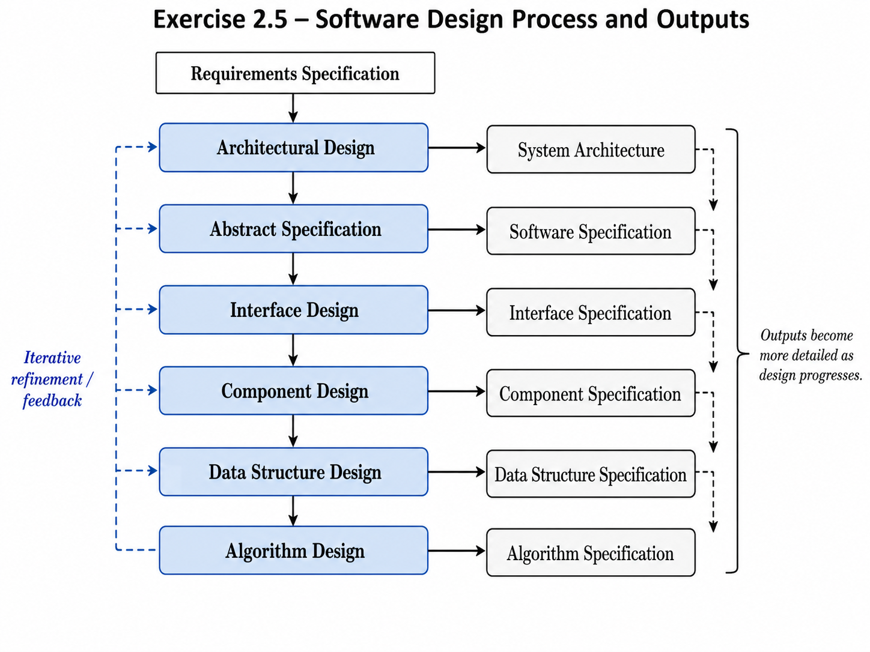

Exercise 3
Find two SE-related video clips online and write short description for them (120 to 200 words each). Concisely explain what they present, their significance for Software Engineering, and why you think the video clips are worthwhile watching. The videos should have a length of between 2:00 and 10:00 minutes (they can be excerpts from longer videos, in which case indicate your selected start and stop time). Provide the complete and correct links for them (make sure they are clickable and give access to the right videos).
STUDENT:
SOLUTION: | Link: https://www.youtube.com/watch?v=Pv5-EZTBUYk  This video explains requirements engineering, which is an important early activity in software engineering. It presents requirements engineering as the process of finding out what users and customers need from a software system before the system is designed and built. The video covers the basic idea of collecting, analyzing, documenting, and validating requirements. This connects well with Sommerville because requirements are a major part of the software process and help developers understand what the system should do.  The video is worthwhile because it is short, simple, and suitable for beginners. It helps viewers understand why unclear or incomplete requirements can lead to software failure. It is also useful because requirements engineering appear in almost every software project, especially business and user-focused systems. Students watching this video can quickly understand the purpose of requirements before studying more detailed topics such as specification, validation, and requirements management.  Link: https://www.youtube.com/watch?v=v4mylTmx4bo  This video introduces the Software Development Life Cycle, usually called SDLC. It explains the main stages used to develop software, such as planning, analysis, design, development, testing, deployment, and maintenance. These stages are closely related to Sommerville’s explanation of software process activities: specification, development, validation, and evolution. The video gives a quick overview of how software moves from an initial idea to a working product.  The video is worthwhile because it gives a clear “big picture” of software engineering. It is especially helpful for students who are new to the subject because it shows how the different activities are connected instead of treating them as separate topics. The short length also makes it easy to review before learning more detailed process models such as waterfall, incremental development, and reuse-oriented development.

Course Project Task 3
Complete the general project description.
STUDENT:
SOLUTION:

Course Project Task 4
Write a paragraph about your choice of software process model for your project.
STUDENT:
SOLUTION:

Assignment for Lecture 5-6:
Lect 5
Exercise 4.4
Write a set of non-functional requirements for the ticket-issuing system, setting out its expected reliability and response time.
STUDENT:
SOLUTION: | -The system should be available during normal station working hours, with only a small amount of downtime allowed, about 1 to 2%.  -The system should respond quickly, about 2 seconds when the user chooses a destination or moves to the next screen.  -A normal ticket purchase should be completed within 30 seconds if the payment system is working properly.  -The system should check the user’s credit card and PIN within 10 seconds.  -If the transaction fails, the system should cancel it safely and clearly tell the customer what happened within 5 seconds.  -The system should print the correct ticket after a successful payment.  -The system should not charge the customer unless the ticket has been successfully issued.  *The numbers used for these requirements will vary depending on organization's approach and client's demand.

Exercise 4.5
Using the technique suggested here, where natural language descriptions are presented in a standard format, write plausible user requirements for the following functions:
- An unattended petrol (gas) pump system that includes a credit card reader. The customer swipes the card through the reader then specifies the amount of fuel required. The fuel is delivered and the customer's account debited.
- The cash-dispensing function in a bank ATM.
- The spelling-check and correcting function in a word processor.
STUDENT:
SOLUTION: | Unattended Petrol Pump System  - Function: Automated fuel delivery and credit card payment.  - Description: The system shall allow customers to purchase fuel independently using a card reader and a control interface at the pump.  - Inputs: Credit card data from the card reader and the required fuel amount or value entered by the customer.  - Processing:  - The system validates the credit card and checks the available credit limit.  - The system records the amount of fuel requested by the user.  - The system opens the pump valve to deliver fuel and monitors the actual quantity dispensed.  - The system automatically debits the customer's account based on the final fuel cost.  - Outputs: Dispensed fuel and transaction receipt (printed or digital).  ATM Cash-Dispensing Function  - Function: Withdrawal of cash from personal bank accounts.  - Description: The ATM must provide the ability for users to withdraw a specific amount of cash after successful identity authentication.  - Inputs: Valid Authentication PIN and the specific amount of cash to be withdrawn.  - Processing:  - The system verifies the customer’s current account balance.  - The system confirms that the withdrawal amount is within the card's limit and the machine's available cash supply.  - The system debits the corresponding amount from the user's bank account.  - The system triggers the mechanical unit to count and dispense the cash through the delivery slot.  - Outputs: Physical cash and an updated account balance notification.  Spelling-Check and Correcting Function  - Function: Detection and correction of orthographic errors in text.  - Description: The word processor must scan document content to identify words that do not match the system dictionary and suggest accurate alternatives.  - Inputs: Text content being edited and the selected language for the check.  - Processing:  - The system compares every word in the document against a built-in dictionary database.  - The system flags suspected spelling errors (e.g., using a red underline).  - The system suggests a list of words with similar structures based on context.  - The system replaces the error with the user's chosen word or ignores it as requested.  - Outputs: Corrected text and a completion report for the spelling check.

Course Project
Define the user requirements for your software.
STUDENT:
SOLUTION:

Lect 6
Exercise 3
Who are Stakeholders in the MHC-PMS?
STUDENT:
SOLUTION: | In Sommerville’s MHC-PMS case study, the key stakeholders include patients, doctors, nurses, medical receptionists, and IT staff. The related stakeholder list also includes medical ethics managers, health care managers, and medical records staff.

Exercise 7.4
The LIBSYS system has to include support for cataloguing new documents where the system catalog may be distributed across several machines. What are likely to be the most important types of non-functional requirements associated with the cataloguing facilities?
STUDENT:
SOLUTION: | Some of the most important types of non-functional requirements are:  - Performance requirements  - Reliability requirements  - Availability requirements  - Consistency requirements  - Security requirements  - Interoperability requirements  - Usability requirements

Exercise 7.5
Using your knowledge of how an ATM is used, develop a set of use-cases that could serve as a basis for understanding the requirements for an ATM system.
STUDENT:
SOLUTION: | The actors are: Bank customer, bank system and ATM operator.  Set of ATM usage are:  - Insert card: The customer inserts a bank card into the ATM to start a session.  - Authenticate user: The customer enters a PIN, and the ATM verifies it with the bank system.  - Withdraw cash: The customer selects an amount, and the ATM dispenses cash if the account has enough money.  - Check balance: The customer requests the current balance of their account.  - Deposit cash or cheque: The customer deposits money or a cheque into their account.  - Transfer funds: The customer transfers money from one account to another.  - Print receipt: The ATM prints a receipt after a transaction if the customer requests it.  - Change PIN: The customer changes their account PIN after successful authentication.  - End session / eject card: The customer finishes using the ATM, and the card is returned.  - Refill cash: Staff refill the ATM with cash.  - Run maintenance check: Staff check the ATM hardware, software status, printer paper, and cash dispenser  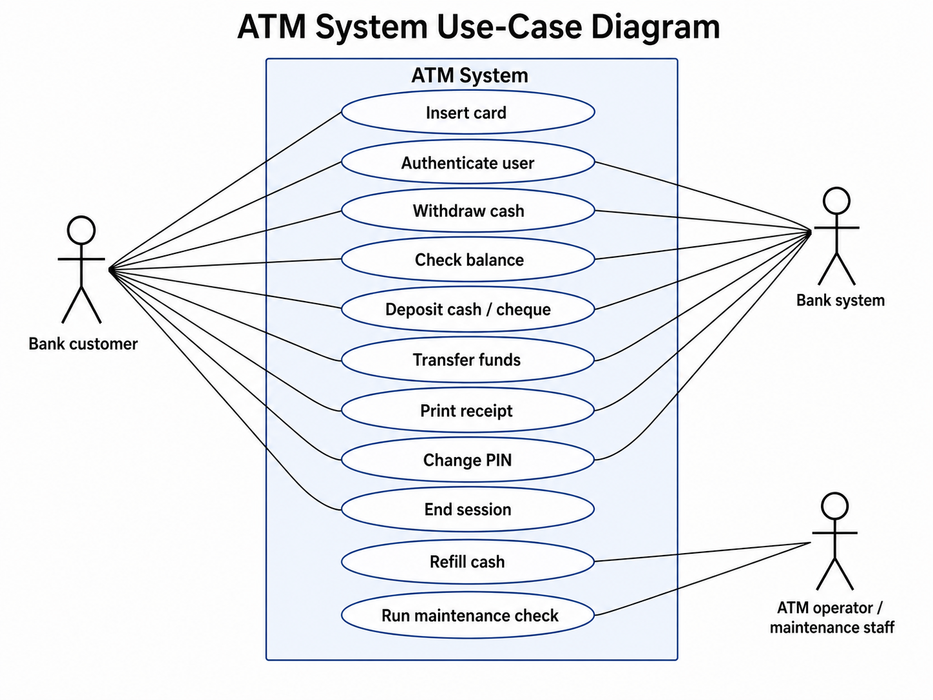

Course Project
Write Feasibility Study and develop your System Requirement.
STUDENT:
SOLUTION:

Course Project
Write a paragraph about your choice of software process model for your project.
STUDENT:
SOLUTION:

Contribution Summary Table
Lecture | Exercise / Task | Topic | Contributor
Lecture 1-2 | Exercise 1 | Software introduction and type
Lecture 1-2 | Exercise 2 | Web impact on SE
Lecture 1-2 | Exercise 3 | Problems without SE principles
Lecture 1-2 | Exercise 4 | Application type and Internet example
Lecture 1-2 | Exercise 1.1 | Software costs / software beyond programs
Lecture 1-2 | Exercise 1.2 | Generic vs custom software
Lecture 1-2 | Exercise 1.3 | Software product attributes
Lecture 1-2 | Exercise 1.8 | Doomsday realistic software failure scenario
Lecture 3 | Exercise 1 | Waterfall model summary
Lecture 3 | Exercise 2 | Waterfall model example
Lecture 4 | Exercise 2.1 | Generic process models for systems
Lecture 4 | Exercise 2.2 | Incremental development vs real-time systems
Lecture 4 | Exercise 2.5 | Software design activities and outputs
Lecture 4 | Exercise 3 | Two SE-related video descriptions
Lecture 4 | Course Project Task 3 | General project description
Lecture 4 | Course Project Task 4 | Process model choice
Lecture 5 | Exercise 4.4 | NFRs for ticket-issuing system
Lecture 5 | Exercise 4.5 | User requirements in standard format
Lecture 5 | Course Project | User requirements for project
Lecture 6 | Exercise 3 | Stakeholders in MHC-PMS
Lecture 6 | Exercise 7.4 | LIBSYS non-functional requirements
Lecture 6 | Exercise 7.5 | ATM use cases
Lecture 6 | Course Project | Feasibility study and system requirements
Lecture 6 | Course Project | Process model paragraph

